Amazon Web Services

Life Cycle Management

Life Cycle Management
- It is a way of efficiently managing the objects so that the cost is minimized throughout the lifecycle of the object inside the instance. 1000 lifecycle rules can be configured per bucket
- There are two types of actions:
- Transition actions: in which the storage class for the objects changes
- Expiration actions: where the objects expire and are permanently deleted
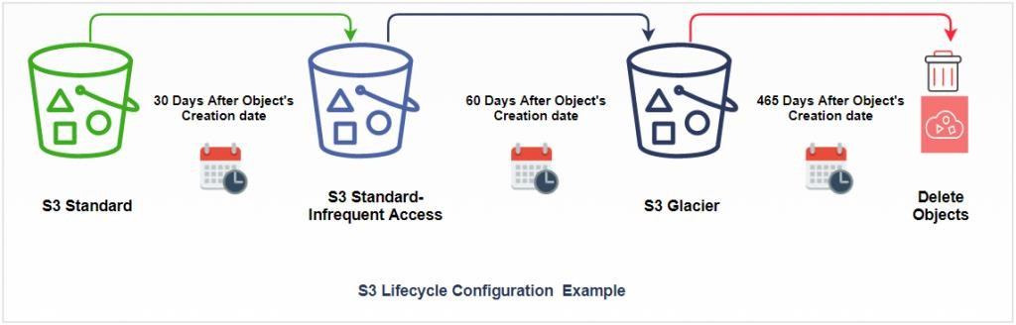

Life Cycle Management - Rules
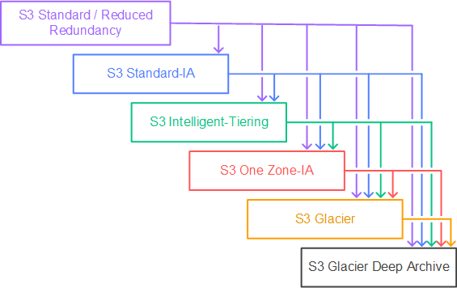

Life Cycle Management
  - Create Bucket

  - Select ACLs Enabled

  - Give Public Access

  - Upload the object

  - Give the Public Access

  - Open bucket

  - Go to the Management tab

Life Cycle Management
  - Click on Create lifecycle rule

  - Enter the Name

  - Select this rule applies to all objects in the bucket

  - Acknowledge the rule

  - Select the rules as per our client's requirements

  - Select storage classes

Life Cycle Management
  - Select the class & enter the days

  - Check the timeline summary

  - Click on create rule

